**Ponte Vecchio Bridge**

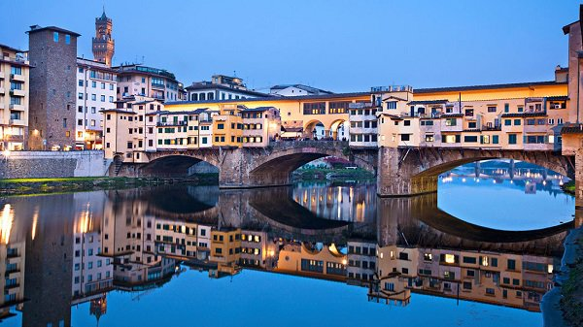Ponte Vecchio pronunciation Italian: [ˈponte ˈvɛkkjo], meaning Old Bridge) is a bridge over the Arno River in Florence of Italy. This is a bridge built in the Middle Ages. The bridge features shops built along the bridge. Initially the butchers were owners of shops along the bridge but now the store mainly sells jewelry, art goods and souvenirs. It has been described as Europe's oldest entire stone arch bridge. Bridges are not for vehicles, only pedestrians. The bridge was built in Roman times (in 996) with the purpose of connecting the town hall of Palazzo Vecchio and Palazzo Pitti. The small houses on the bridge date back to 1333. In the Vasari corridor on the side of the bridge are portraits of leading Italian and European artists.

**Special**

In addition, the unique point that always attracts the curiosity of visitors is that the locks are hooked on many places on the bridge. Couples from many countries around the world often come here to get a lock, write down the names of two people and hook them on the bridge, and the key was thrown into the river. They believe that by doing so, their feelings will be forever endured.